**LoRaWAN MULTICHANNEL OUTDOOR GATEWAY**

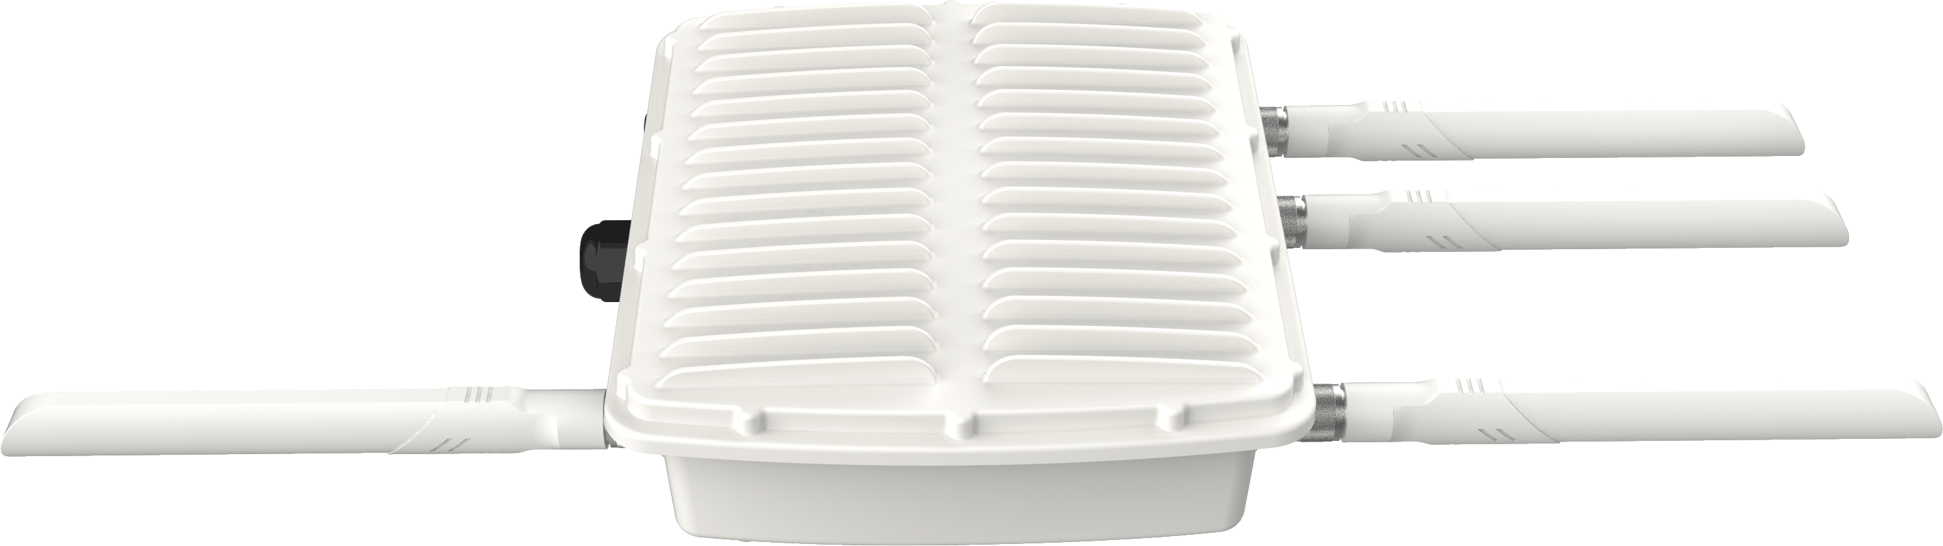

**Description**

Ursalink LoRaWAN Gateway is based on LoRa technology, built perfectly for developing Internet of Things applications, it features edge computing capability with Python programming supported to match different use cases in the field. This customizable device is designed to bring hardware and software flexibility for overcoming the loT technical challenges.

**Specification**

* Memory: 8 GB Flash, 512 MB DDR3 RAM
* Power Supply: PoE PD (Default), 9-48 VDC (Optional), 90-240 VAC (Optional)
* Network Protocol: PPP, PPPoE, TCP, UDP, DHCP, ICMP, NAT, HTTP, HTTPs,  
  DNS, ARP, NTP, SMTP, Telnet, SSH2, DDNS, etc.
* VPN Tunnel: OpenVPN , IPsec , PPTP , L2TP , DMVPN , GRE
* Serial Port: Transparent, TCP Client/Server, UDP, Modbus Gateway
* Cellular (Optional): 2 × SIM Slot, Support for Global GSM/3G/4G LTE Frequency Bands
* Wi-Fi (Optional): IEEE 802.11b/g/n/ac
* Ethernet: 1 x 10/100/1000 Mbps
* Console: 1 x Console
* GPS+GLONASS: Yes
* Serial: NA
* I/O: NA
* Channel: 8
* Frequency: 865-867MHz
* Sensitivity: -140dBm Sensitivity @292bps
* Output Power: 27dBm Max
* Protocol: V1.0 Class A/Class C and V1.0.2 Class A/Class C
* Operating Temperature: -40°C to +70°C (-40℉ to +158℉) Reduced cellular performance above 60°C
* Storage Temperature: -40°C to +85°C (-40℉ to +185℉)
* Relative Humidity: 0% to 95% (non-condensing) at 25°C/77℉
* Ingress Protection: IP67
* Mounting: Wall or Pole Mounting
* Certifications: RoHS, CE, FCC